**UMUC CMIS 242 Project 1 Test Plan**

Files: Employee.java, Salesman.java, Executive.java, P1Driver.java, inputData.txt, P1Utils.java

Author: John Bernat

Date: 22Jan2016

**Description:**

This program takes a properly formatted file with a list of employees/Salesmen/Executives and there salaries and then generates a report and displays all information along with their annual salaries and an overall average salary for each year.

The program contains a superclass, multiple subclasses and multiple static methods used to run calculations and data formatting.

**Test Case table – Project 1:**

|  |  |  |  |  |
| --- | --- | --- | --- | --- |
| **Test Case objective** | **Input** | **Expected Output** | **Actual Output** | **Pass/Fail** |
| 1: Missing the input file (or wrong file name) | The file is not included in the current folder of a wrong name is used | A warning message is displayed indicated the file is missing or incorrectly referenced | ? | ? |
| 2: Input file contains a 5 mixed year sets of data | 5 lines of properly formatted data | Two tab delimited report tables with annual average salary calculations | Two tab delimited reports | Pass |
| 3: Input file contains no data | The file is empty | Two blank reports will be generated | Two blank reports | Pass |
| 4: Input file contains over 100 sets of data | 100 lines of properly formatted data | Two tab delimited report tables with annual average salary calculations | Two tab delimited reports with calculations | Pass |

**Test Case 1 -** Missing the input file (or wrong file name):

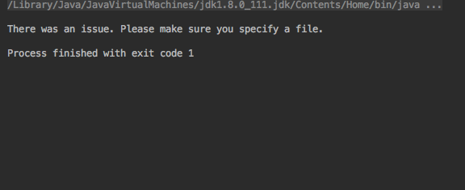

**Test Case 2 -** Input file contains a 5 mixed year sets of data:

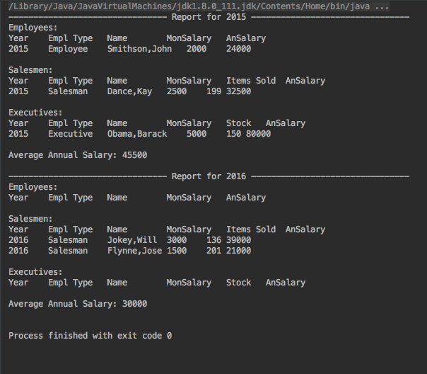

**Test Case 3 -** Input file contains no data:

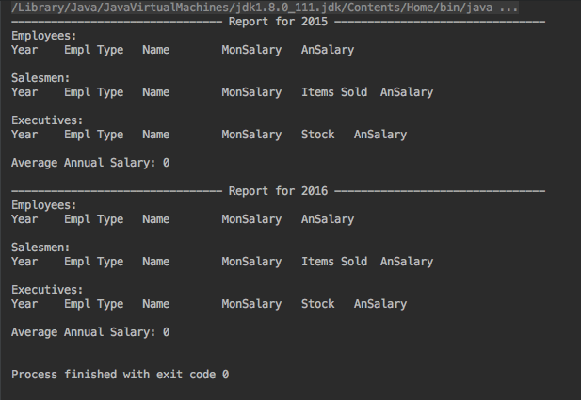

**Test Case 4 -** Input file contains over 100 sets of data:

